Cats and dogs and cows and shoes.
Tomatoes and potatoes and videos and zoos.
Scarves and elves and shelves and leaves.
Boys and trays and guys and keys,
Babies and lollies and ponies and puppies.
Kisses and foxes and watches and brushes.

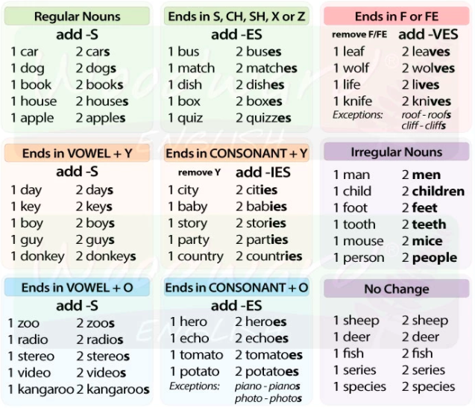

Kassid and koerad and lehmad and kingad.
Tomatid and kartulid and videod and loomaaiad.
Sallid and päkapikud and riiulid and puulehed.
Poisid and kandikud and kutid and võtmed.
Beebid and pulgakommid and ponid and kutsikad.
Suudlused and rebased and käekellad and harjad.

Cats and dogs and cows and shoes.
Tomatoes and potatoes and videos and zoos.

scarf elf shelf leaf
Scarves and elves and shelves and leaves.

boy tray guy key
Boys and trays and guys and keys,

baby lolly pony puppy
Babies and lollies and ponies and puppies.

kiss fox watch brush
Kisses and foxes and watches and brushes.

